# Scenario 1: Locate and Allocate Resource

## Scenario Description

* All functionality relating to locating an available resource to meet the specified skill requirement and allocating that resource to a particular job.

## Version Control

|  |  |  |  |
| --- | --- | --- | --- |
| Version # | Date | Author | Description |
| 1.0 | 13/06/2019 | Brodie Osborn | Initial Version |

## Test Scripts

The following scripts will cover this scenario:

* 1.1 Successfully allocate resource
* 1.2 No available resource found (No resource available with required skill)
* 1.3 No available resource found (Resource has required skill but is already assigned)

## Use Case

* Allocate Resource

## Test Components/Requirements

This test scenario covers the following high-level test requirements (see scripts below for specific requirements covered by each test script):

* Ensure that resources can be located to meet a skill requirement
* Ensure that resources can be allocated to a project
* Ensure that resources cannot be allocated to multiple projects with conflicting time constraints

## User Groups

* Project Manager
* Resource

## Script 1.1: Successfully Allocate Resource

### Script Description

* A Project Manager is able to search for and locate a resource to fill a skill requirement and allocate that resource to the project.

### Testing Requirements

This test script covers the following specific testing requirements:

* Ensure that resources can be located to meet a skill requirement
* Ensure that resources can be allocated to a project

### Setup

* Test Project 1 must exist with a requirement for Java from 15/06 to 15/07
* Test Resource 1 must exist with the Java skill and not assigned to any other projects

### Teardown

* Test Resource 1 should be removed from Test Project 1

### Script Steps

| **Step #** | **Test Action** | **Expected Results** | **Pass/ Fail** |
| --- | --- | --- | --- |
| 1 | Click “Projects” Button | Open Projects Page |  |
| 2 | Click Test Project 1 | Open Test Project 1 window |  |
| 3 | Click the Locate Resource Icon on the Java skill requirement | Open the Resource Search window  Test Resource 1 should be listed as available |  |
| 4 | Click the Allocate button for Test Resource 1 | Test Resource 1 is allocated to Test Project 1  Return to Test Project 1 window  Java skill requirement should now have Test Resource 1 allocated to it |  |

### 

### Test Execution

|  |  |  |  |  |
| --- | --- | --- | --- | --- |
| Date/Time | Tester | Test ID | Test Phase | Status |
| 9/9/2019 | Aaron | 001 | IOCM | Successful |

## Script 1.2: No Resource can meet the Skill Requirement

### Script Description

* A Project Manager is unable to locate a resource for the skill requirement as no resource exists with that skill.

### Testing Requirements

This test script covers the following specific testing requirements:

* Ensure that resources can be located to meet a skill requirement

### Setup

* Test Project 1 must exist with a requirement for Black Magic from 15/06 to 15/07
* No resource that exists should have the Black Magic skill

### Teardown

* N/A

### Script Steps

| **Step #** | **Test Action** | **Expected Results** | **Pass/ Fail** |
| --- | --- | --- | --- |
| 1 | Click “Projects” Button | Open Projects Page |  |
| 2 | Click Test Project 1 | Open Test Project 1 window |  |
| 3 | Click the Locate Resource Icon on the Black Magic skill requirement | Open the Resource Search window  No resources should be listed as available |  |
| 4 | Click the Cancel button | Return to Test Project 1 window |  |

### Test Execution

|  |  |  |  |  |
| --- | --- | --- | --- | --- |
| Date/Time | Tester | Test ID | Test Phase | Status |
| 9/9/2019 | Aaron | 002 | IOCM | Successful |

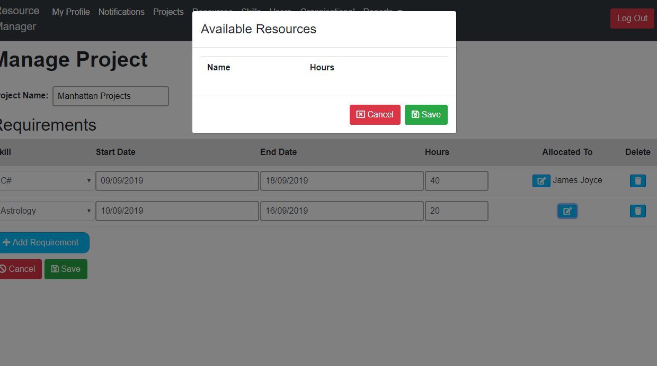

## Script 1.3: No Resource available during the timeframe specified

### Script Description

* A Project Manager is unable to locate a resource for the skill requirement as any available resources with that skill are already allocated.

### Testing Requirements

This test script covers the following specific testing requirements:

* Ensure that resources can be located to meet a skill requirement

### Setup

* Test Project 1 must exist with a requirement for Astrology from 15/06 to 15/07
* Test Project 2 must exist with a requirement for Astrology from 15/06 to 15/07
* Test Resource 2 must exist with the Astrology skill and assigned to Test Project 2

### Teardown

* N/A

### Script Steps

| **Step #** | **Test Action** | **Expected Results** | **Pass/ Fail** |
| --- | --- | --- | --- |
| 1 | Click “Projects” Button | Open Projects Page |  |
| 2 | Click Test Project 1 | Open Test Project 1 window |  |
| 3 | Click the Locate Resource Icon on the Astrology skill requirement | Open the Resource Search window  No resources should be listed as available |  |
| 4 | Click the Cancel button | Return to Test Project 1 window |  |

### Test Execution

|  |  |  |  |  |
| --- | --- | --- | --- | --- |
| Date/Time | Tester | Test ID | Test Phase | Status |
| 9/9/2019 | Aaron | 003 | IOCM | Successful |

